1.Please check and make sure 5 xulrunner files and cefsharplib file are in the Documents path of your PC, if not, you can download them from links below:
http://developer.botchief.com/xulrunner29.0.zip
http://developer.botchief.com/xulrunner33.0.zip
http://developer.botchief.com/xulrunner45.0.zip
http://developer.botchief.com/xulrunner60.0_x86.zip
http://developer.botchief.com/xulrunner60.0_x64.zip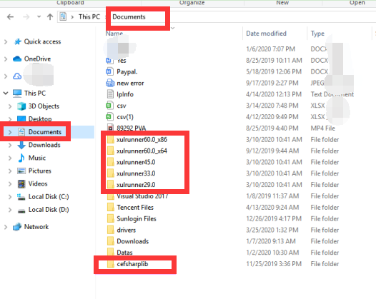
https://drive.google.com/file/d/1mKn7Z_wBzbRffwedyFG7C5aZoaHJAOLq/view?usp=sharing
Unzip the downloaded files and unzip them(if it's prompted the file is empty or damaged, please install a 7-zip tool to unzip them).Put the unzipped files into Documents path and make sure they don't contain double directories, which could happen when you unzip them or move them.

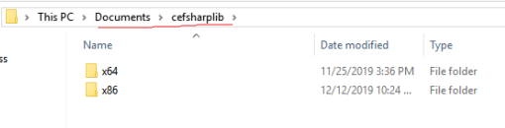
Please check if C:\Program Files (x86)\xulrunner60.0_x64 exists and it cannot be a C:\Program Files (x86)\xulrunner60.0_x64\xulrunner60.0_x64. ( This is very important.)
2.Please download and install X86 and X64 versions of vc++2013 and vc++2015-2019:
https://www.microsoft.com/en-us/download/details.aspx?id=40784
https://support.microsoft.com/en-us/help/2977003/the-latest-supported-visual-c-downloads
If they are installed successfully, you can find them in control panel like this:
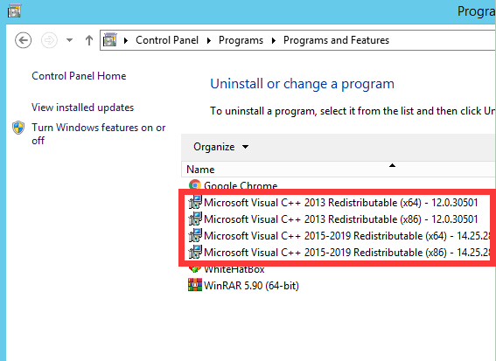

- Download and install .net 3.5 and .net 4.8 if they are not installed on your device:
https://dotnet.microsoft.com/download/dotnet-framework

