Manual for TrafficBotPro v2

This documentation focuses on explaining some typical tasks. Please read it carefully.

Task 1, bring traffic for your website through direct visit.
Create a task under "Browse directly" tab, then enter your website link in "Website" filed, then click Next button to setup settings for the next page. You can setup a stay time spend on your page in "Load Time" filed, the unit is millisecond. And you can setup a run times in "Enter total number of run times for this task" filed. After the settings are done for this page, just click “Next ” button to view the next settings page. After all are done, then you can click Start button to run it.
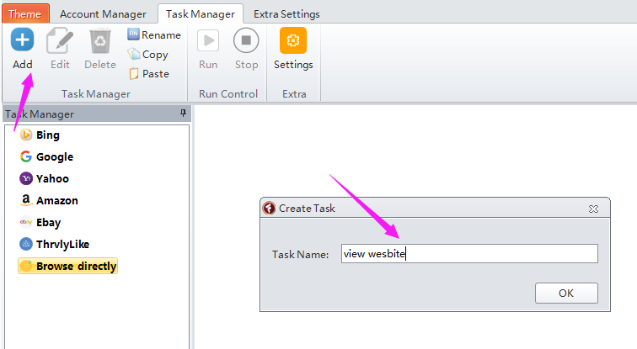
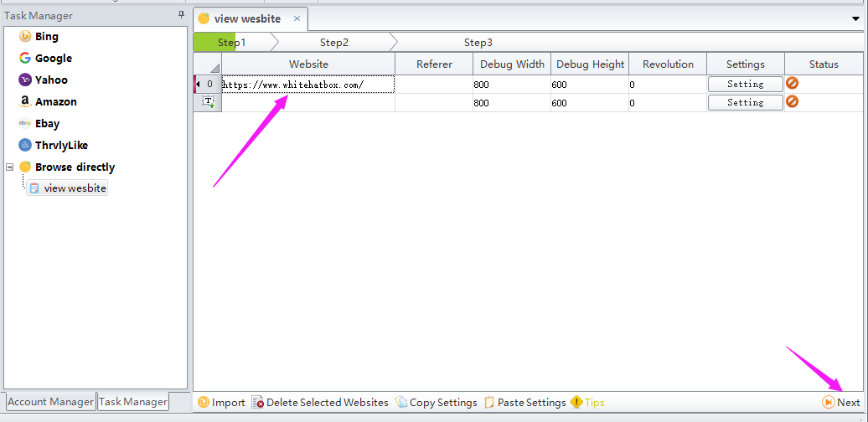
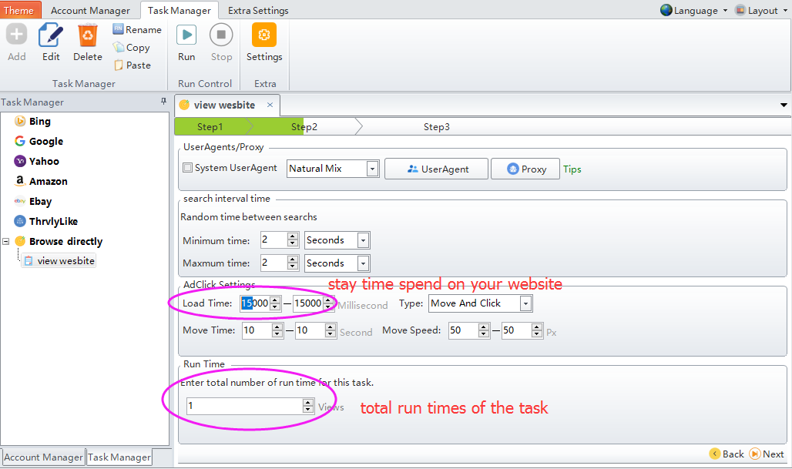
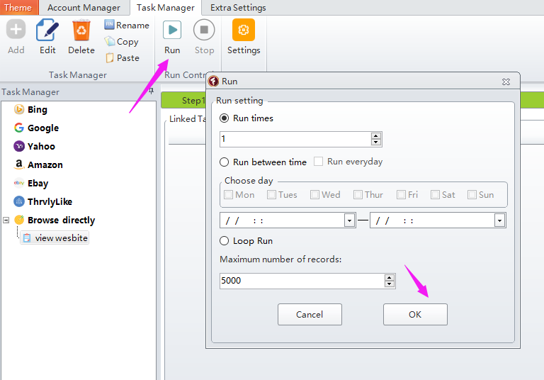

Proxy is necessary if you want to bring many views to your website. You can use the scrape proxy tool built in the software to scrape free proxies from website to run. Or you can upload your own paid proxies to the task to run.
We have a manual on how to use the Scrape Proxy tool.
Following is the settings for proxy:
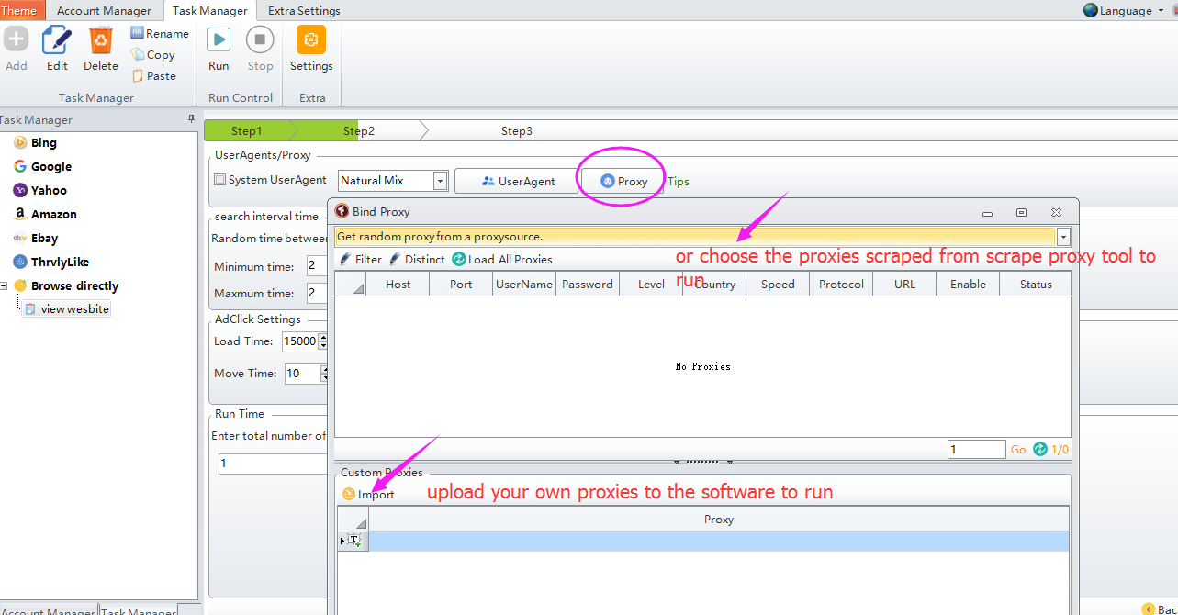

Task 2, bring traffic through keyword search on Google.
Please note that task will run successfully only when this keyword can be used to find your website on Google search results.
Create a task under "Google" tab, then enter your website link in "Website" filed, then click Next button to setup settings for the next page. You can enter the search keyword in "Keyword" tab. And setup a page number in "PageNumber" filed to search your website within these search results page. You can setup a stay time spend on your page in "Load Time" filed, the unit is millisecond. And you can setup a run times in "Enter total number of run times for this task" filed. After the settings are done for this page, just click Next button to view the next page. After all are done, then you can click Start button to run it.
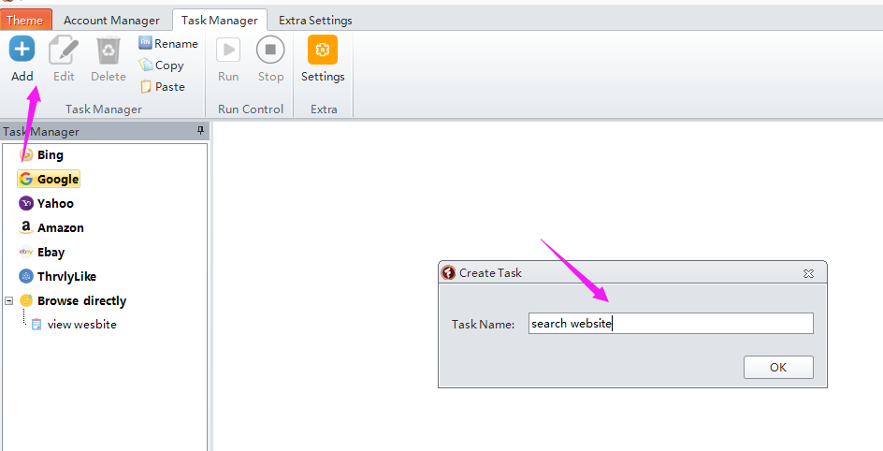
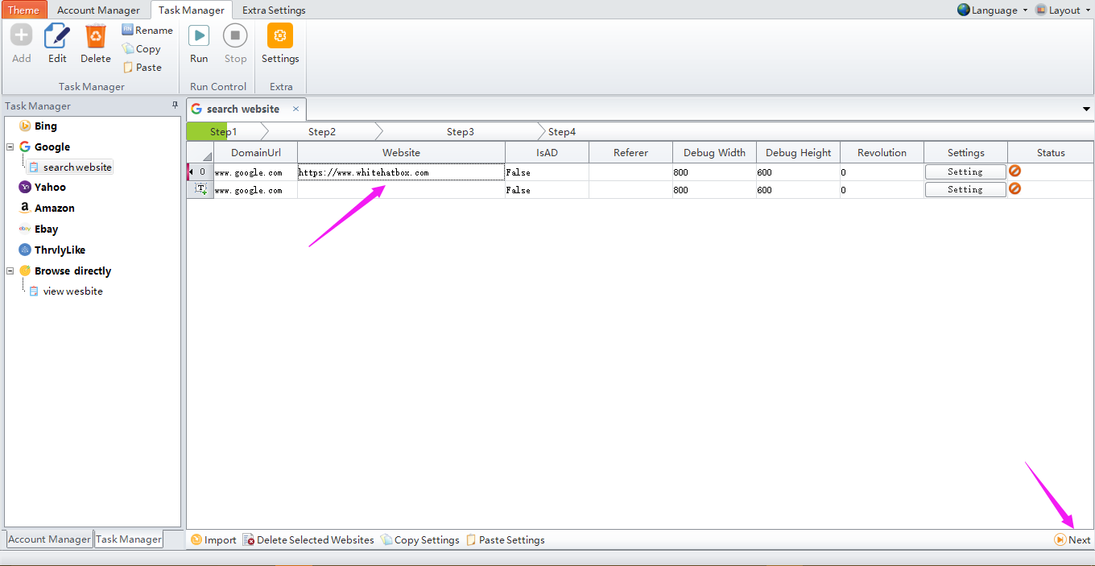
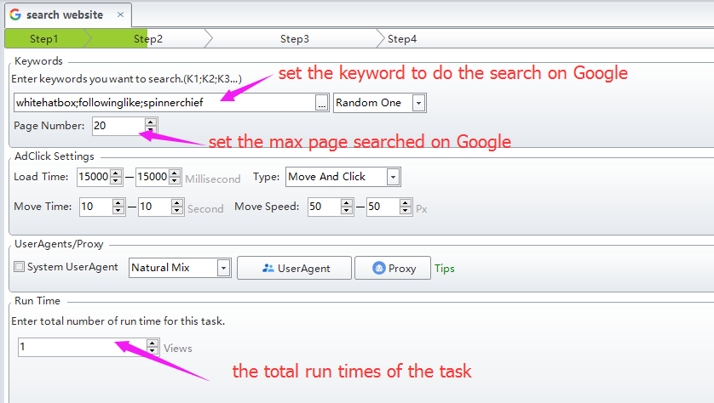
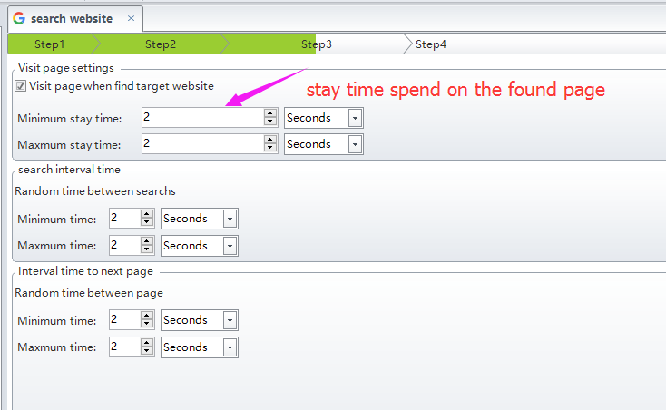

Explanation for some options:

Task 3, Click Google ads to cost your competitor budget
Please note that task will run successfully only when the ads has been shown up in Google search page through keyword
- Create a task under "Google" tab, then enter your ads page link in "Website" filed. The website link is taken from Google search page.
Eg: if the keyword i entered in Google is “Apple”, and the ads you want to click is as follows. Then please copy and paste the ads link to the software “Website” field.
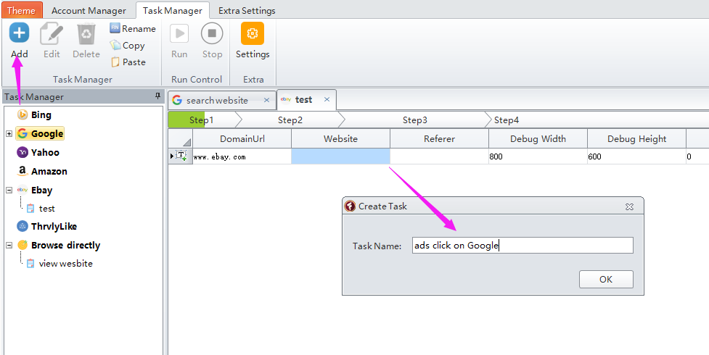
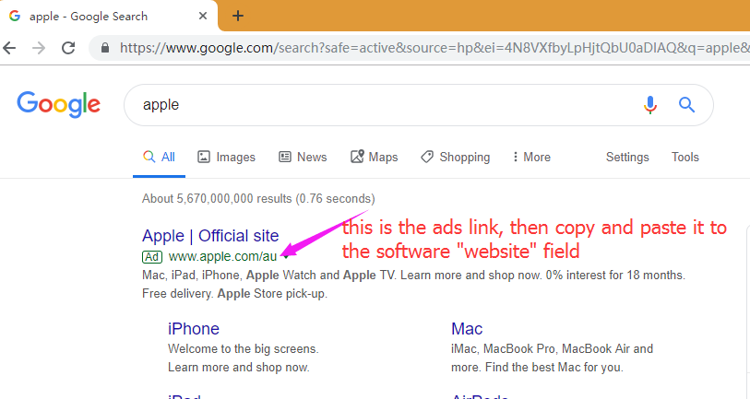
- Enter ”True ” in “IsAD” filed, then click “Next” button to complete the next settings.

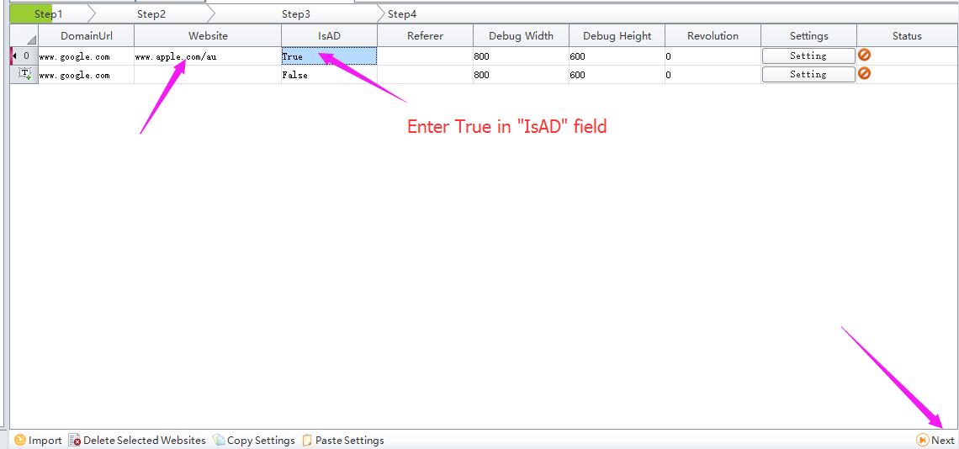
- Enter the search keywords in "Keyword" filed. And setup the max page number in "PageNumber" filed to search the ads within the page you set. Set the total run times of the task in “Enter total number of run time for this task” field.
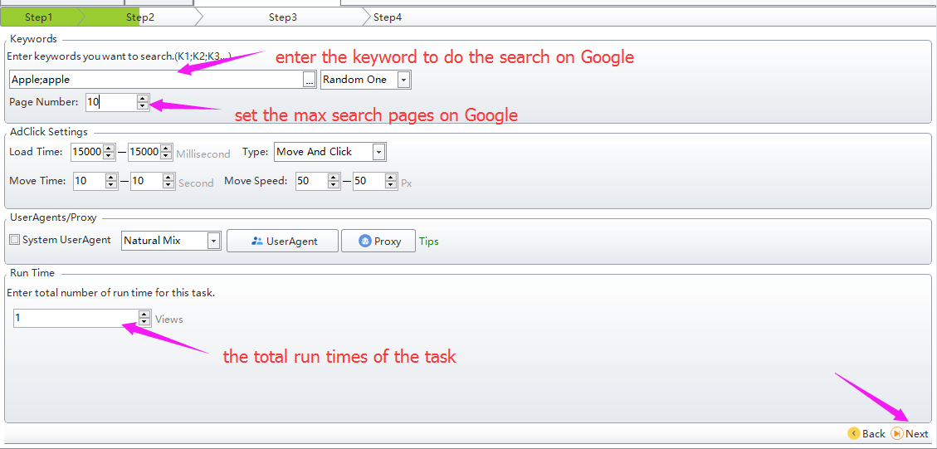

- Set a stay time in “Visit page when find target website” field spend on the ads page when software found and visited it
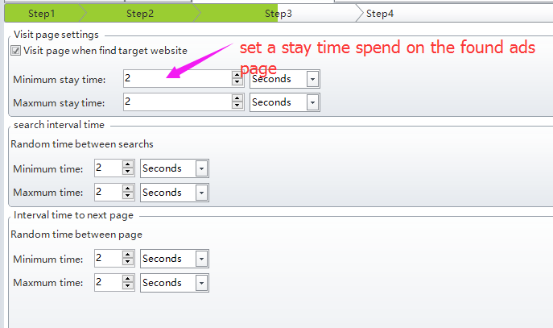

Task 4, click your website adsense to earn money for your own.
we have explained the detailed steps in TrafficBotPro forum, you can refer to:
https://www.whitehatbox.com/bbs/BBSPost?postid=6293
Following are the steps with screenshot attached. And we will take this website as example:
https://finance.yahoo.com/quote/AAPL/
- Create a task under "Google" tab, then enter your ads page link in "Website" filed. Then click “Setting” button to the adsense setting page.
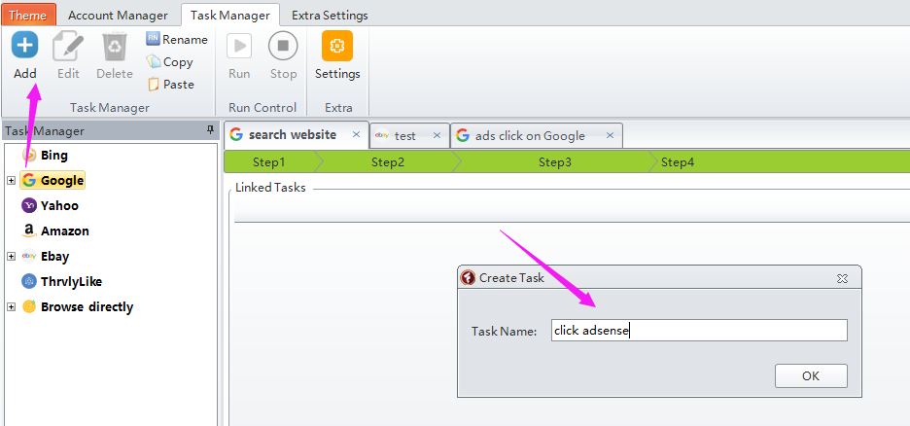
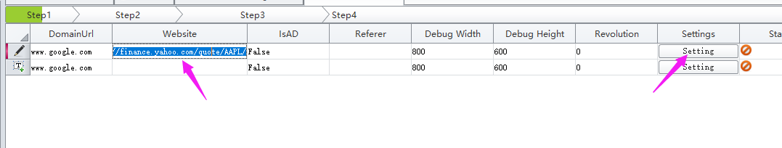
- Click “Select Control” button to random click one of the elements in the website, then click “Delete Selected Row” button to remove all found conditions.
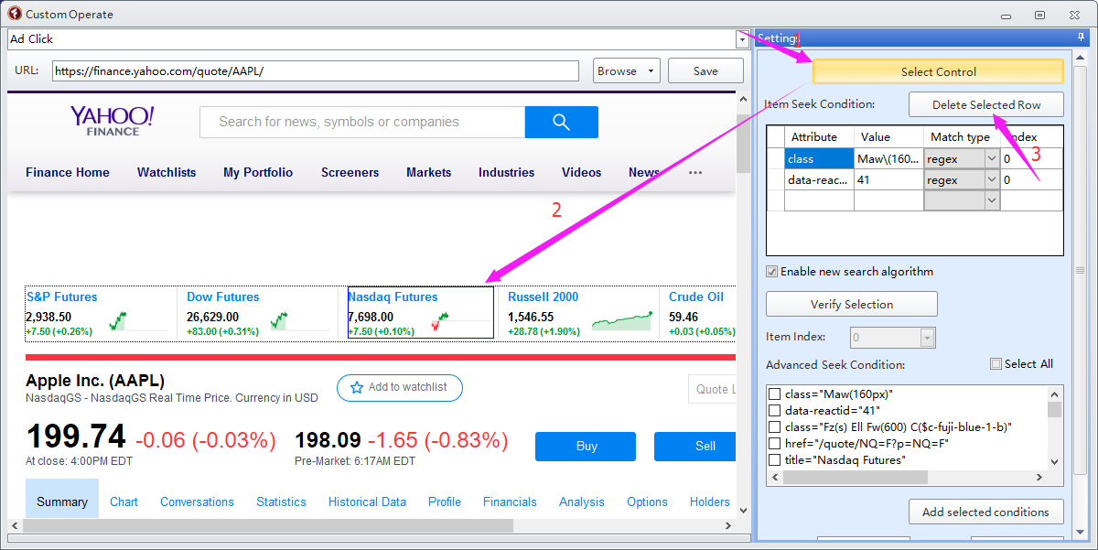
- Enter “Iframe” in “Tag” filed, remove value in “Iframe”, and uncheck the “Enable new search algorithm” option. Then click “Verify Selection” to see how many adsense it can find in your website
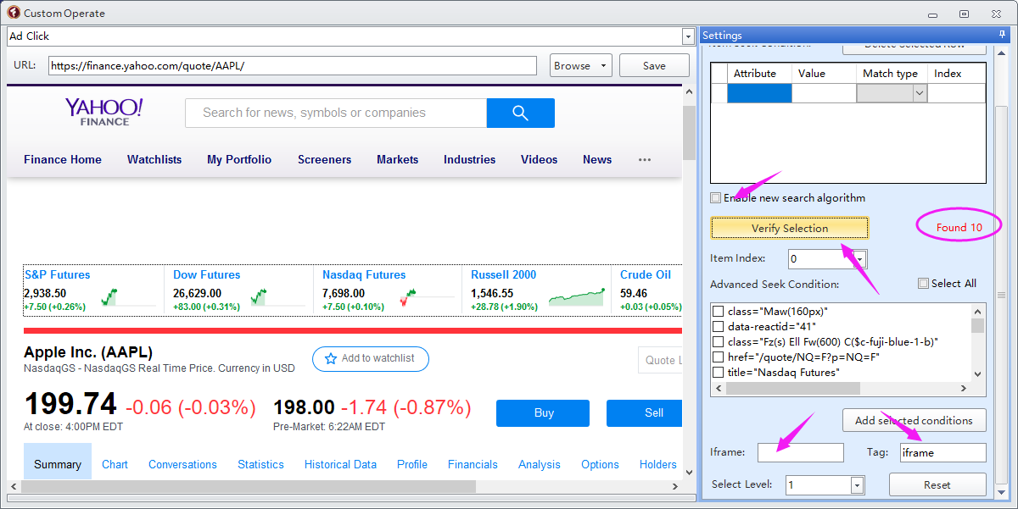
- The number shown in the “item Index” filed drop-down box represents the total Adsense it found on this page. Choose a number from the drop down list to target to the adsense you want to click. Software will mark the adsense with green when it is found.

After setup it successfully, then just click Save button to save the settings, then click Next button to complete the next steps in the main settings interface.
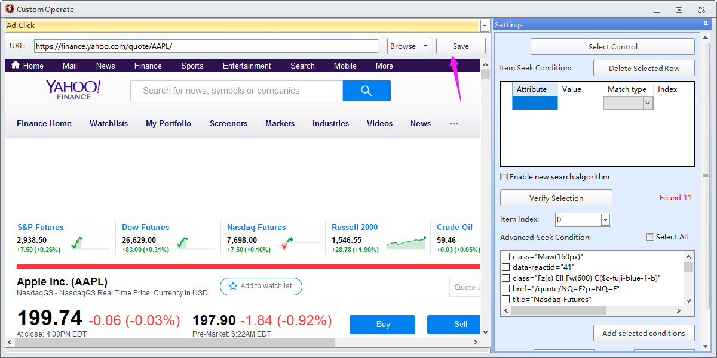
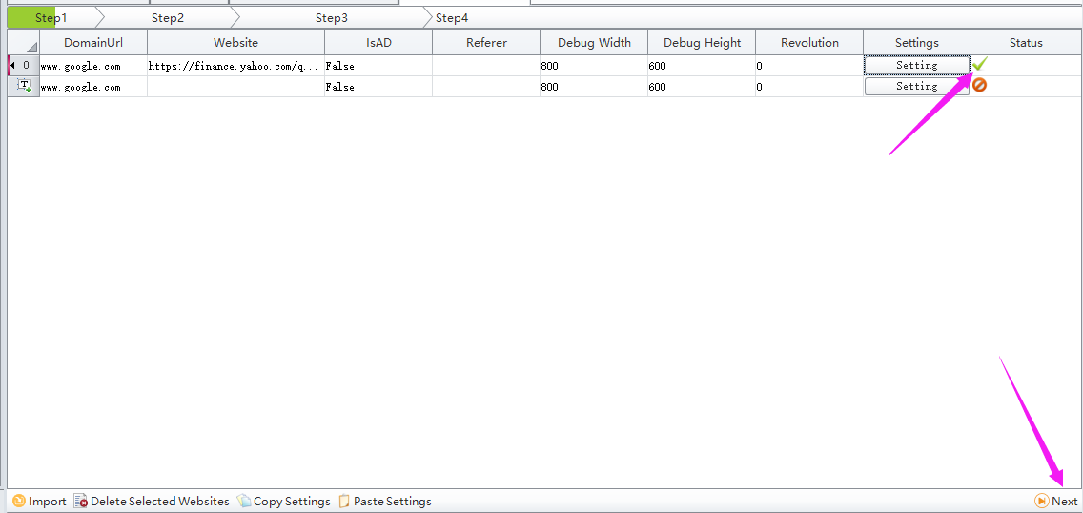

Explanation for some functions:
Referral: Referral traffic is used to describe visitors to your site that come from direct links on other websites rather than directly or from searches. For example, other sites that like what you have to say or sell may post a link recommending your site. You can also try to drive your own referral traffic by leaving links on other blogs or forums you have joined. Pay-per-click ads also count as referral traffic.
Refferal traffic works only when other users click in from other websites that recommend you to visit or from links that you place in blogs or forums.

page number: maximum number of pages the task will visit on Google/Yahoo/Bing....etc. search results pages.
Sample:
If your site ranks on page 5 of Google search results page by keyword search, and if the page number is set to 1 or 2, or 3, or 4, then task will run failure, because the first 4 search results pages can not find your website.
But if the page number is set to 10, then when the software visits page 5 of the search page and finds your website, the software will directly visit your website, and then perform the following operations. Instead of continuing to search for page6, page 7....of the Google search results page. Which means if you have no idea which page your website ranked via keyword search, then you can set the page number value to be large.

ThrvlyLike: thrvylike is a website. If you do not need to do any operation in this website, then you do not need to add your thrvylike account.
If you want to run other websites with account login in, you can provide the details for us. We can help you custom develop it based on your needs if you are interested in it.

IntervalTime:
1, Visit page when find target website: the length of time spent at a page once found.
eg: if you search your website on Google, after found your website and visit it, then it will stay on your website for around 20-30 seconds.
2, Interval time to next page: the pause time to continue to search on next page in Google, Yahoo, Bing........
eg: if you want to search your website on Google, and here are 5 search results. When bot finished searching your website at 1st page, then it will pause 2-5 seconds, then will continue to do the search on 2nd page.....
3, Search interval time: the delay to do the search with next keyword.
4, Load and AdClick Move Settings: the length of time spent at a ads page once found.
Adclick mouse movement time, mouse movement speed

